* What is SDLC?

SDLC or the Software Development Life Cycle is a process that produces software with the highest quality and lowest cost in the shortest time possible. SDLC provides a well-structured flow of phases that help an organization to quickly produce high-quality software which is well-tested and ready for production use.

* What is software testing?

Software testing is the process of checking the quality of a product before launching. It measures the software's completeness to the single functional (or non-functional) attributes and whether it has fulfilled the business logic or shown us the missing gaps in requirements that need immediate tackles.

* What is agile methodology?

Agile Methodology meaning a practice that promotes continuous iteration of development and testing throughout the software development lifecycle of the project. In the Agile model in software testing, both development and testing activities are concurrent, unlike the Waterfall • What is SRS?

Description about how the system is expected to perform. It is usually signed off at A software requirements specification (SRS) is a document that captures complete the end of requirements engineering phase.

* What is oops?

Object-Oriented testing is a software testing process that is conducted to test the software using object-oriented paradigms like, encapsulation, inheritance, polymorphism, etc. The software typically undergoes many levels of testing, from unit testing to system or acceptance testing • Write Basic Concepts of oops?

Object-Oriented Programming, also known as OOPs concepts in python, is what lets us develop applications using an Object-Oriented approach. It does so by clubbing together similar or related behaviors and properties and converting them into objects. In this article, I will explain the basic concepts of Object-Oriented Programming in Python programming, oop fundamentals, and features of oops. You must know Python programming before you continue.

* What is object?

An object represents an individual, identifiable item, unit, or entity, either real or abstract, with a well-defined role in the problem domain. An "object" is anything to which a concept applies. This is the basic unit of object oriented programming (OOP). That is both data and function that operate on data are bundled as a unit called as object.

* What is class?

A class represents an abstraction of the object and abstracts the properties and behavior of that object. An object is a particular instance of a class which has actual existence and there can be many objects (or instances) for a class

* What is encapsulation?

Encapsulation is the practice of including in an object everything it needs hidden from other objects. The internal state is usually not accessible by other objects. Encapsulation is placing the data and the functions that work on that data in the same place. While working with procedural languages, it is not always clear which functions work on which variables but object-oriented programming provides you framework to place the data and the relevant functions together in the same object.

Encapsulation in Java is the process of wrapping up of data (properties) and behavior (methods) of an object into a single unit; and the unit here is a Class (or interface). Encapsulate in plain English means to enclose or be enclosed in or as if in a capsule. In Java, a class is the capsule (or unit)

* What is inheritance?

Inheritance means that one class inherits the characteristics of another class. This is also called a “is a” relationship

One of the most useful aspects of object-oriented programming is code reusability. As the name suggests Inheritance is the process of forming a new class from an existing class that is from the existing class called as base class, new class is formed called as derived class.

* What is polymorphism?

Polymorphism means “having many forms”. It allows different objects to respond to the same message in different ways, the response specific to the type of the object.

The ability to change form is known as polymorphism.

There is two types of polymorphism in Java

Compile time polymorphism(Overloading)

Runtime polymorphism(Overriding)

* Write SDLC phases with basic introduction?

Given below are the various phases:

(1)Requirement gathering and analysis

(2)Design

(3)Implementation or coding

(4)Testing

(5)Deployment

(6)Maintenance

#1) Requirement Gathering and Analysis

During this phase, all the relevant information is collected from the customer to develop a product as per their expectation. Any ambiguities must be resolved in this phase only.

#2) Design In this phase, the requirement gathered in the SRS document is used as an input and software architecture that is used for implementing system development is derived.

#3) Implementation or Coding

Implementation/Coding starts once the developer gets the Design document. The Software design is translated into source code. All the components of the software are implemented in this phase.

#4) Testing

Testing starts once the coding is complete and the modules are released for testing. In this phase, the developed software is tested thoroughly and any defects found are assigned to developers to get them fixed.

Retesting, regression testing is done until the point at which the software is as per the customer’s expectation. Testers refer SRS document to make sure that the software is as per the customer’s standard.

#5) Deployment

Once the product is tested, it is deployed in the production environment or first UAT is done depending on the customer expectation.

In the case of UAT, a replica of the production environment is created and the customer along with the developers does the testing. If the customer finds the application as expected, then sign off is provided by the customer to go live.

#6) Maintenance

After the deployment of a product on the production environment, maintenance of the product i.e. if any issue comes up and needs to be fixed or any enhancement is to be done is taken care by the developers.

* Explain Phases of the waterfall model?

The Waterfall Model was the first Process Model to be introduced. It is also referred to as a linearsequential life cycle model. It is very simple to understand and use. In a waterfall model, each phase must be completed before the next phase can begin and there is no overlapping in the phases.

Waterfall Model - Design

Waterfall approach was first SDLC Model to be used widely in Software Engineering to ensure success of the project. In "The Waterfall" approach, the whole process of software development is divided into separate phases. In this Waterfall model, typically, the outcome of one phase acts as the input for the next phase sequentially.

The following illustration is a representation of the different phases of the Waterfall Model.

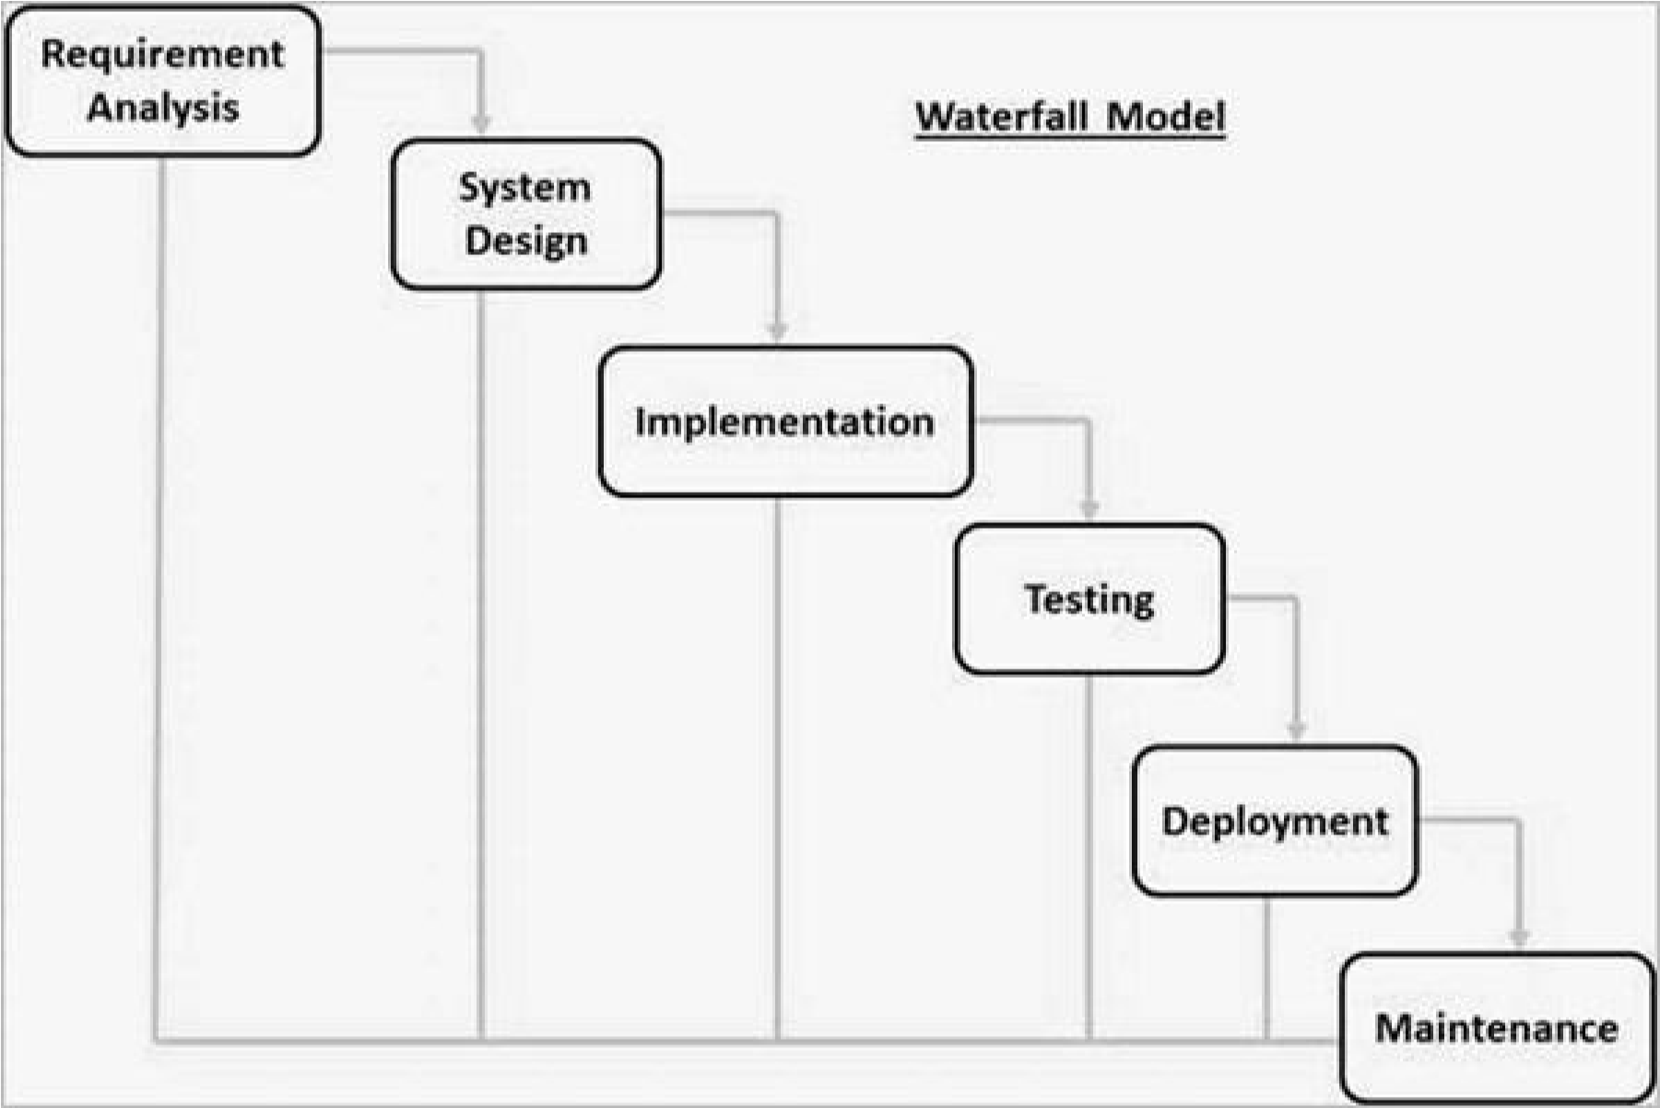

* Write phases of spiral model?

Spiral model is one of the most important Software Development Life Cycle models, which provides support for Risk Handling. In its diagrammatic representation, it looks like a spiral with many loops. The exact number of loops of the spiral is unknown and can vary from project to project. Each loop of the spiral is called a Phase of the software development process. The exact number of phases needed to develop the product can be varied by the project manager depending upon the project risks. As the project manager dynamically determines the number of phases, so the project manager has an important role to develop a product using the spiral model.

* Write agile manifesto principles?

The Agile Manifesto is a document that identifies four key values and 12 principles that its authors believe software developers should use to guide their work. Formally called the Manifesto for Agile Software Development, it was produced by 17 developers during an outing on Feb. 11-13, 2001, at The Lodge at Snowbird ski resort in Utah.

* Explain working methodology of agile model and also write pros and cons.?

Agile model is a process of software development (such as other software development methodologies – waterfall model, V-model, iterative model, etc.), however, the Agile development model is also a type of incremental model. Software develops in incremental, rapid cycles. In English, Agile means ‘the ability to move quickly and easily’ and respond to change rapidly – this is an important aspect of Agile software development.

**Advantages of Agile Methodology:**

In Agile methodology the delivery of software is unremitting.

The customers are satisfied because after every Sprint working feature of the software is delivered to them.

Customers can have a look of the working feature which fulfilled their expectations.

If the customers has any feedback or any change in the feature then it can be accommodated in the current release of the product.

In Agile methodology the daily interactions are required between the business people and the developers.

In this methodology attention is paid to the good design of the product.

Changes in the requirements are accepted even in the later stages of the development.

An Agile/Scrum approach can improve organizational synergy by breaking down organizational barriers and developing a spirit of trust and partnership around organizational goals.

**Disadvantages of the Agile Methodology** :

In Agile methodology the documentation is less.

Sometimes in Agile methodology the requirement is not very clear hence it’s difficult to predict the expected result.

In few of the projects at the starting of the software development life cycle it’s difficult to estimate the actual effort required.

Because of the ever-evolving features, there is always a risk of the ever-lasting project.

For complex projects, the resource requirement and effort are difficult to estimate.

* Draw Usecase on online book shopping?

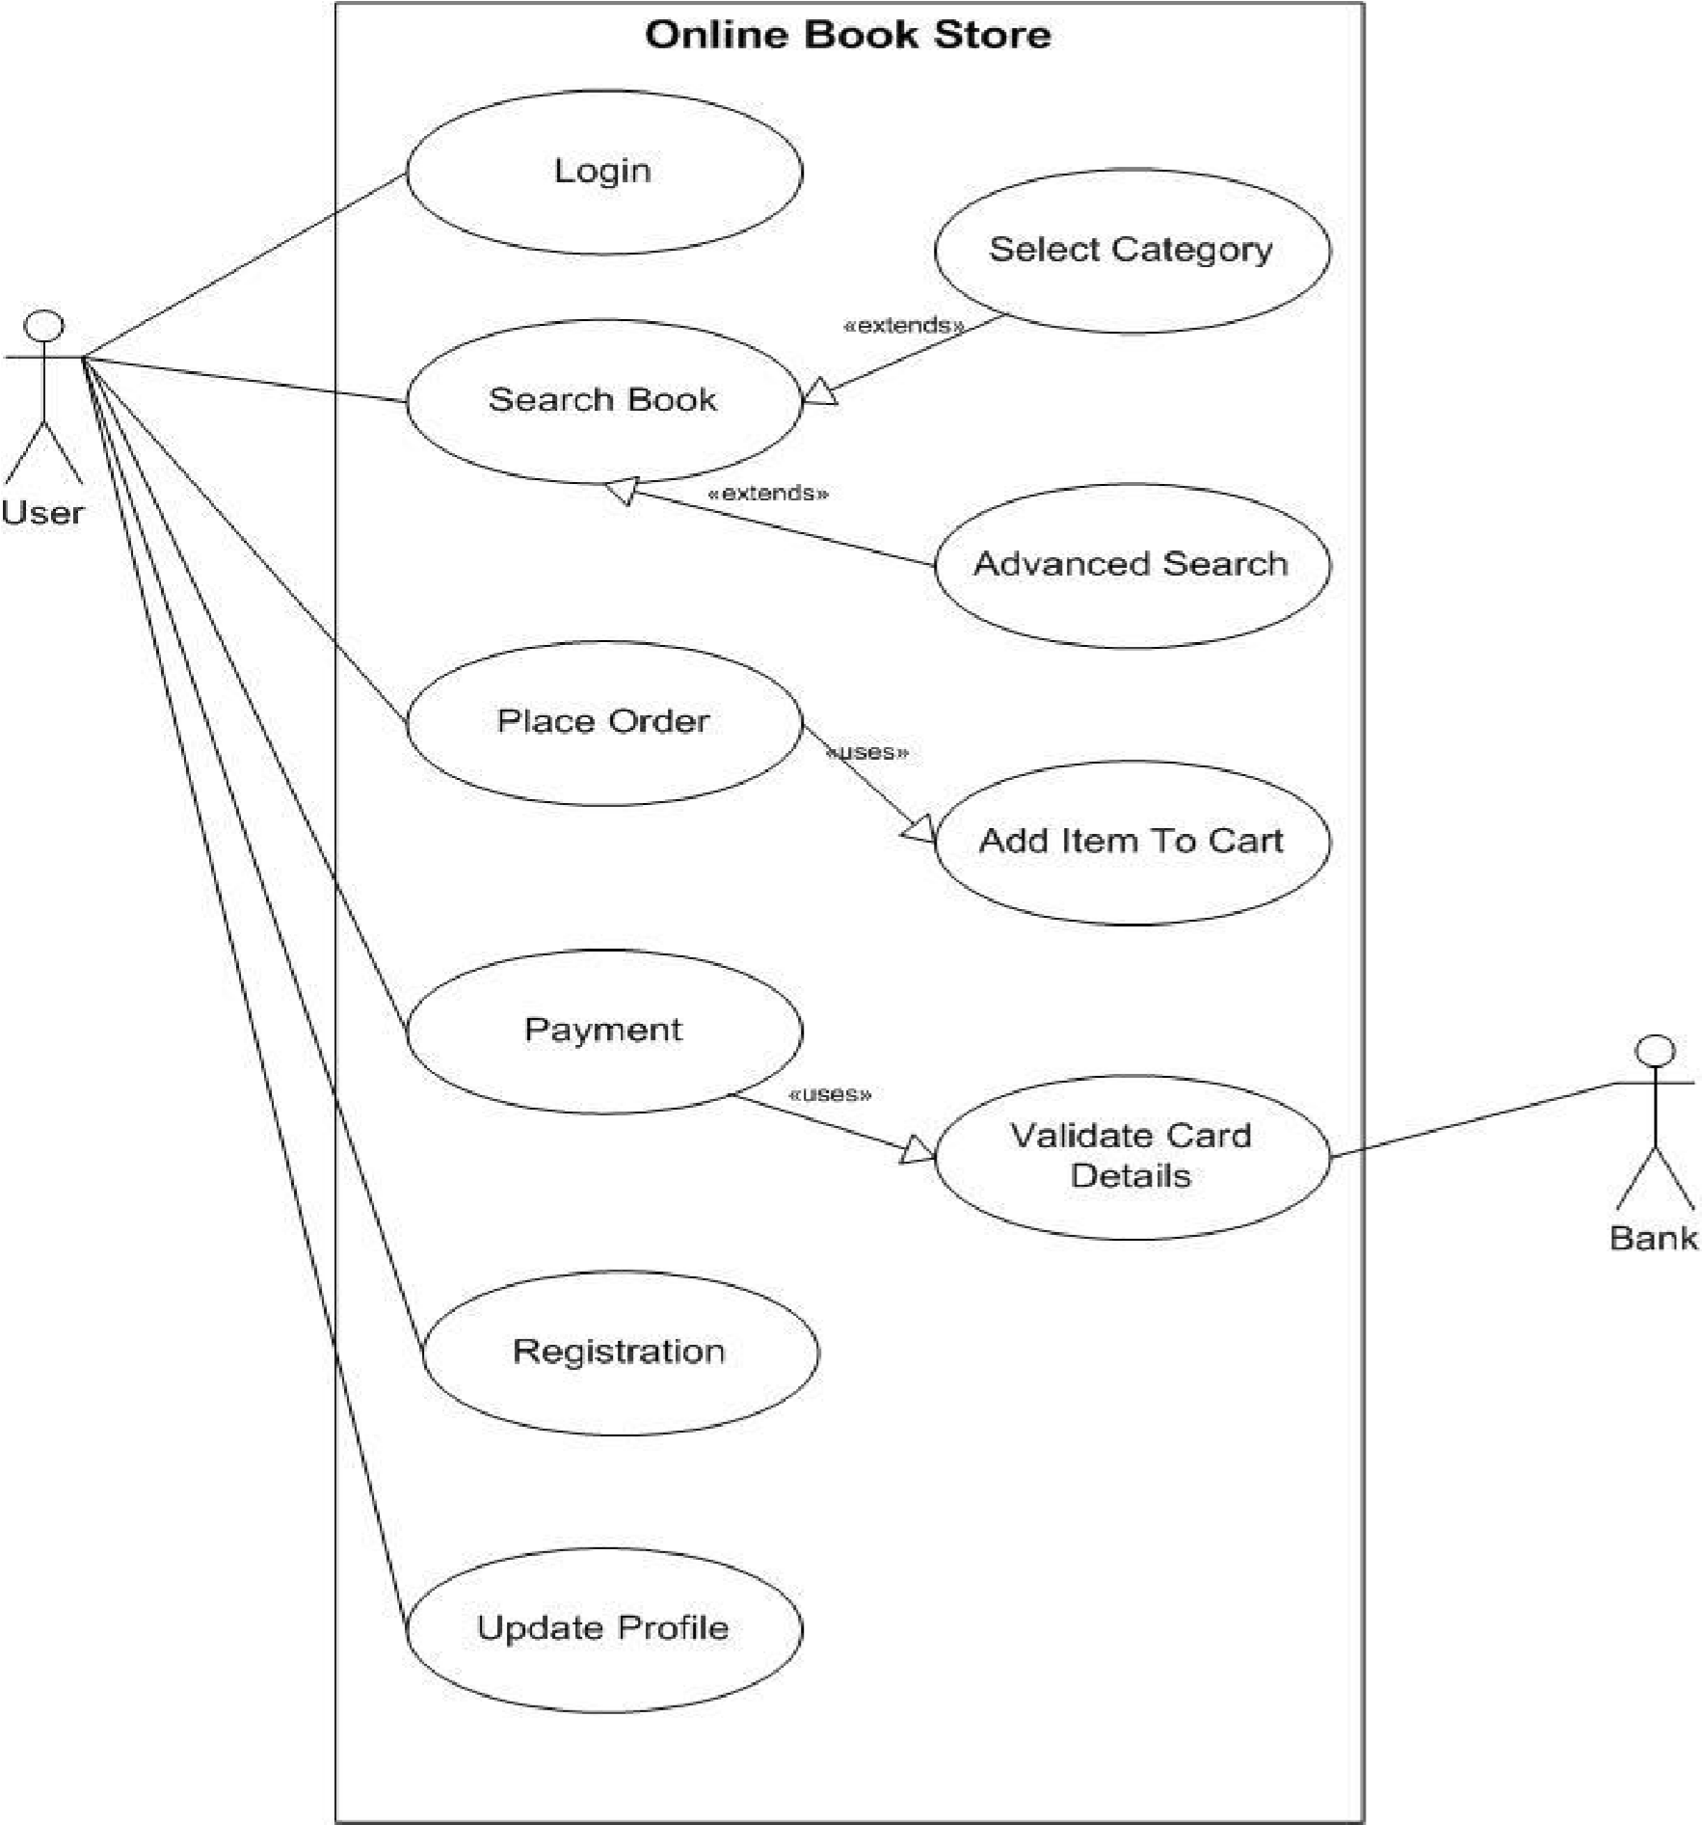

* Draw usecase on Online shopping product using COD?

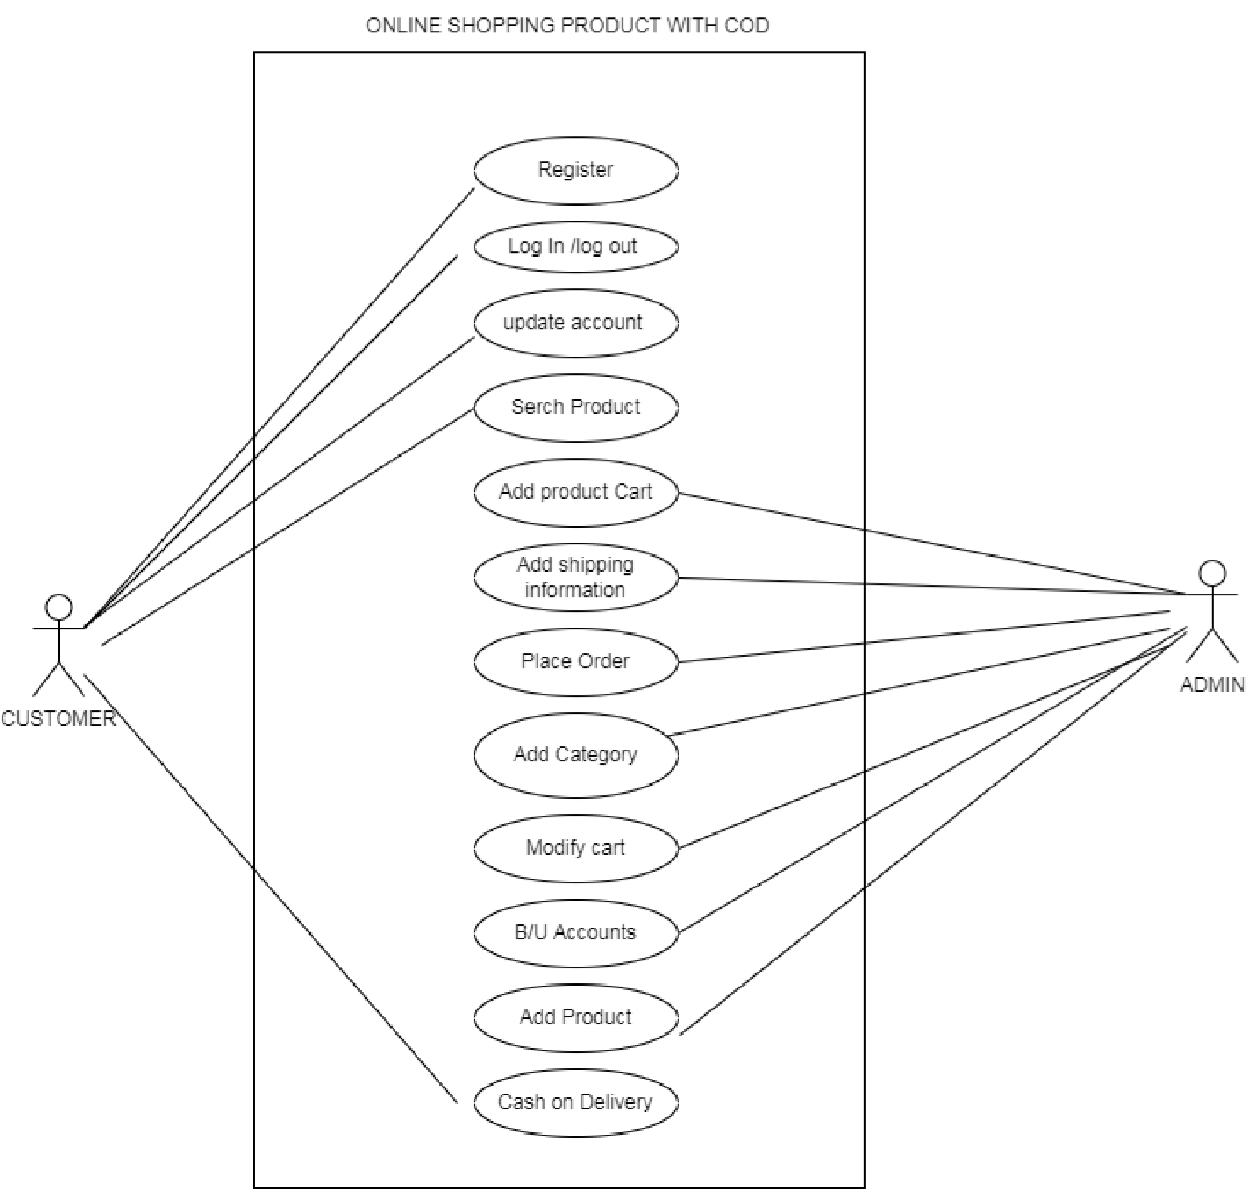

* Draw Usecase on online bill payment system (paytm)?

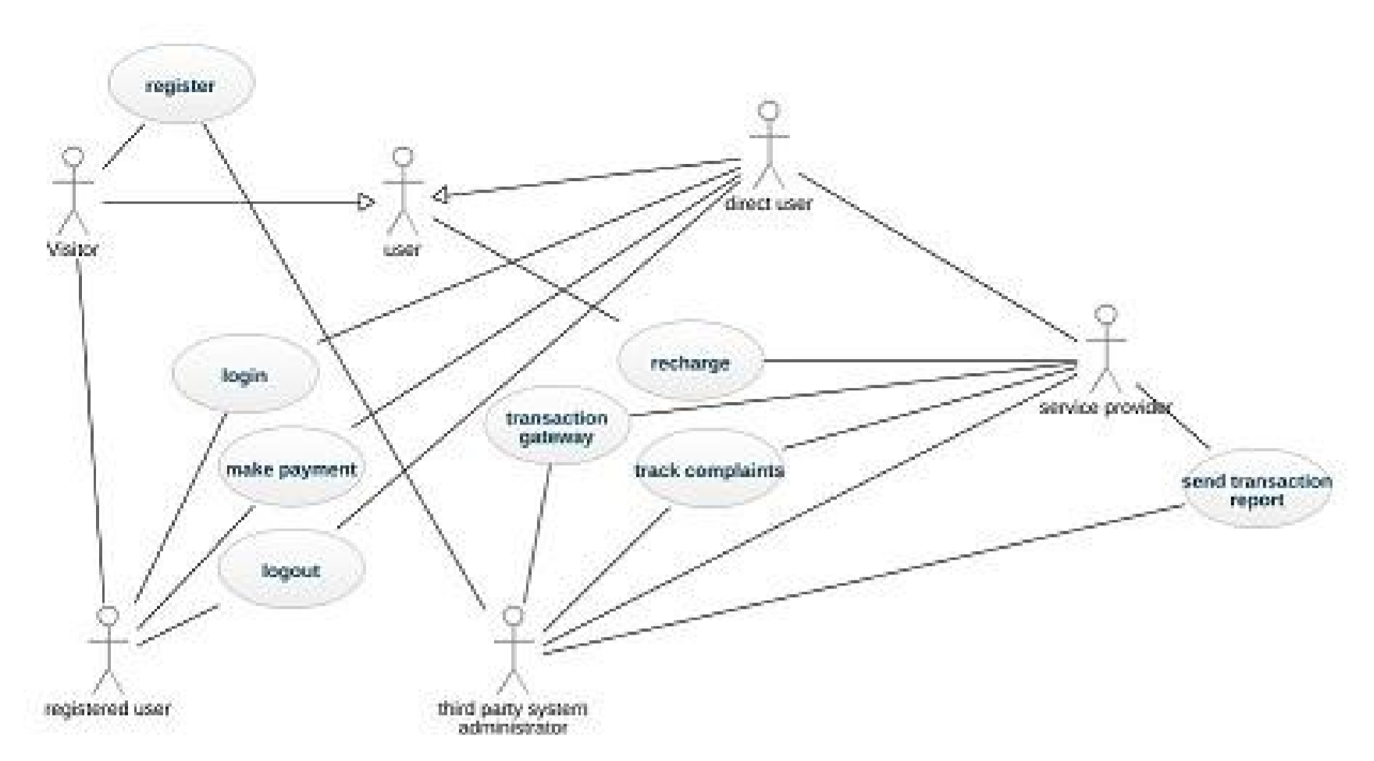

* Draw usecase on Online shopping product using payment gateway?

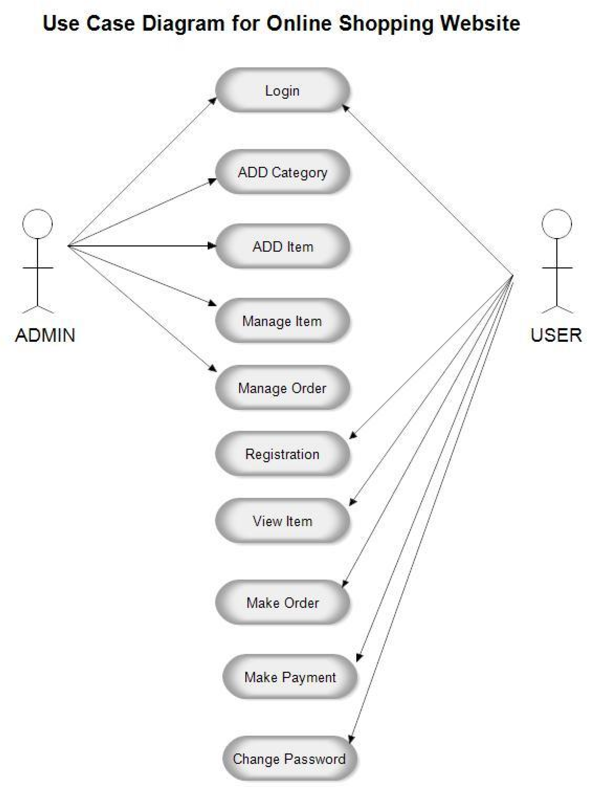

ASSIGMENT -1 ASSIGMENT -1 ASSIGMENT -1 ASSIGMENT -1 ASSIGMENT -1 ASSIGMENT -1 ASSIGMENT -1 ASSIGMENT -1 ASSIGMENT -1